Project team 5 - Financial Literacy Service

Team Members: Josh Marsico, Himaja Goda, Jayden Parsons, Michael Simms

PROJECT PROPOSAL
1. Problem Statement
Making investing or financial planning more accessible to those without a formal background in finance. Many inexperienced and beginning investors tend to lean towards managed index funds and managed portfolios. This is often due to a lack of confidence and understanding that stems from a disconnect between evaluating current news, market trends, and financial terminology.
The goal of this tool is to create an educational research assistant that can contextualize and explain financial information with citations.
Standalone application/service for now.
2. Target Users and Stakeholders
Stakeholders: Financial/investment firms
Target Users: Beginner investors with an interest in building their own portfolio and understanding the market better.
3. Data Sources
Describe the datasets, APIs, data streams, documents, or other data sources that will be used.
Web search - Tavily API - provide financial terminology and documentation background
Historical stock data associated with headlines/events
News stories and geopolitical events that have impact - Tavily API
YahooFinance API - provide accurate financial data
Alpha Vantage API - provides historical financial data
Correlate news/events data with financial data through similarity search and date/time. “Do these events correlate with stock trends in the related field at this time?” Ideally this can be done semantically with an agent evaluating them.
4. AI Use Case
Identify a potential AI use case, and describe the AI-enabled capabilities your system will support.
Primary use case:
Intelligent search to retrieve relevant information related to stock portfolio or interests and explain with context. Using a search tool within the finance API.
Supporting capabilities:
Question answering as beginner guidance for new users. Have a RAG system for financial terminology questions and introductory information.
Recommendations in the form of next-step suggestions from user prompting. Listing out options rather than directing the user. Complying with company and government policies.
Trend analysis, evaluate current portfolio against current events, as well as historic data. Display current trends to the user clearly and link to current events.
Knowledge discovery through search API functions, as well as historical data relevant to current decisions or investments.

5. Project Scope and Objectives
Define the project's goals, expected deliverables, assumptions, and limitations.
Goals/Deliverables
- Develop a web-based interface for beginner investors
- Allow users to search for companies or financial topics/areas they are interested in
- Retrieve current and historical market information through API use
- Retrieve relevant financial news or documents
- Retrieve financial terminology and introductory information through web search API use
- Use an AI assistant to explain retrieved information in an accessible manner
- Guardrail layer to rewrite and check responses that may contain directive language for the user. No case of “you should buy this.”
- Link relevant events to stock trends visually for the user
  - Pair events with stock trends: did x-event correlate with a large dip or uptick in y-stock?
  - Visualize both on a timeline for the user
  - Set boundaries for relevance - how far out can an event have impact? What is considered a large enough impact? Did experts also link this event to a trend?
    - Example criteria:
      - Event window: −1 to +3 trading days around the event date
      - Impact threshold: absolute return over the window exceeds 2× the stock's 30-day average daily volatility, and exceeds the sector ETF's return over the same window by at least 1%
      - Only events above threshold get an agent caption; others appear as unlabeled markers
      - Captions must describe the move, not attribute cause

- Give the user beginner learning resources and citations for recommended decisions
  - Expert opinions
Assumptions:
- The user is a beginner with no real prior knowledge.
Limitations:
- Policy and law around financial advising.
- Depth of information that can be retrieved.
- Accuracy of recommendations - disclaimer
- Market data is delayed (15 min or end-of-day), not real-time
- LLM explanations may contain factual errors; all claims are cited so users can verify
- The system does not provide investment advice and is not backtested
  - Backtesting could be really interesting to implement though
- Free-tier API rate limits constrain how many tickers can be refreshed per hour

6. Preliminary High-Level System Architecture
Provide an initial architecture diagram and explain how data will flow through the system.
What is stored locally:
- policy.md
- user profiles (non-sensitive: id, confidence level, financial interests, search history)
- the terminology corpus and its embeddings
- short-TTL caches of prices and news
- ** No credentials, account numbers, or holdings are stored.
Search and retrieve:
- live/current market
- news data
- Historical data
- Financial terminology and introductory information
- Expert opinions
USER -> Agent -> Query -> Tool usage -> Processing -> Output
Query -> Search API -> Response

Data flow, request path:
- User submits a query (ticker, company, or topic) with their profile's confidence level attached.
- The API layer authenticates the session and forwards the query to the agent orchestrator.
- The agent decides which tools to call: market data for prices, news search for recent events, terminology RAG for definitions. Tool results are cached in Redis to respect API rate limits.
- The agent drafts a response with inline citations. The guardrail layer checks it against policy.md and the directive-language classifier; violating text is rewritten or dropped and a disclaimer is appended.
- The API returns the response and any timeline data to the client, and logs the search to the user's history.
Data flow, correlation pipeline (event -> trend):
- News search returns headlines with publish dates for the ticker.
- The event extractor dedupes and dates them into discrete events.
- The price window calculator pulls the ticker and sector-ETF series, computes the abnormal return for each event window, and flags events above threshold.
- Flagged events are sent to the agent for a neutral caption; all events are returned as timeline markers.

7. Preliminary Technology Stack
Identify the technologies your team currently plans to use and briefly justify each choice.
Category | Choice | Justification
Frontend | React + TypeScript, Recharts for the timeline | Most familiar. Recharts handles overlaid time-series and event markers - I think
Backend / API | Python 3.12, FastAPI | Support for concurrent tool calls, fast to prototype
Agent framework | Anthropic Python SDK with native tool use | simple to trace and debug - used before, can swap to openAI
LLM | Claude Sonnet (can be swapped easily) | Strong instruction following for citation and tone constraints
Relational DB | PostgreSQL 16 | Users, profiles, search history
Vector store | pgvector extension | Keeps RAG in the same database as everything else
Embeddings | OpenAI text-embedding-3-small | Cheap - works for smaller scale - used before
Market data | Alpha Vantage (primary), yfinance (fallback) | Alpha Vantage has a free tier with historical daily data.  yfinance is unofficial but good if we hit limits
News / web search | Tavily API  News + websearch | Returns clean and dated results with source URLs for citation - easy for LLMs
Terminology corpus | Scraped public-domain and allowed licensed sources (SEC investor.gov, Federal Reserve education pages) | Avoids licensing issues
Containerization | Docker + docker-compose | One-command local dev with Postgres and the app
Deployment | Render or Fly.io free tier | Enough for a demo - might need to switch to cloud host / deploy
Version control / CI | GitHub, GitHub Actions for lint + tests | Standard

8. Team Organization
Identify team members, preliminary responsibilities, and planned collaboration practices.
Roles and responsibilities - TBD:
Josh -
Himaja -
Jayden -
Michael -
Possible Role Split:
- Frontend + timeline visualization
  - search UI, company page, Recharts timeline
- Backend + data pipelines
  - FastAPI, Postgres, Redis, market/news tool wrappers, correlation pipeline
- Agent + RAG
  - prompt design, tool definitions, terminology corpus ingestion, embeddings
- Guardrails, evaluation, and docs
  - policy.md, output classifier, test set of beginner questions, disclaimer compliance, proposal and final report

Planned meeting/check-in once a week

Sprint 1 Data Exploration and Wrangling
Team Members:

Name | Role(s) | Contribution Area
Josh | Testing API + report | Alpha Vantage finance
Himaja | Testing API | Tavily news search
Jayden | Testing API | yfinance
Michael | Testing API | Tavily web search

1. Sprint Overview
Sprint Goal
Briefly summarize the goals of Sprint 1 and the work completed by your team.
Summary (1–2 paragraphs)
- What data sources are available.
- What information the data contains.
- How the data is structured.
- What data quality issues exist.
- How the data should be transformed and prepared.
- How the data will support future database, processing, and AI components [Keep this question in mind—we will be able to answer it more thoroughly in later modules].
Goals: Each member of the team took one api/data source and wrote a test script to gather sample data and verify the format.

2. Data Source Inventory
Document all datasets, APIs, document collections, streams, or other data sources that will be used in the project.
Data Source Summary Table

Data Source | URL/Access Method | Provider | Format | Estimate Size | Update Frequency | Access Restriction
Tavily | API
yfinance | API | Yahoo Finance | Pandas DataFrame/JSON | Depends on number of stocks and date range | Near real-time/daily market updates | Free, unofficial Yahoo Finance API, intended mainly for personal/research use
Alpha Vantage | API

Data Source 1
Name: Tavily
Description: News and websearch source
Why is this data relevant to the project?
- Handles collection of news stories and headlines
Expected contribution to project objectives:
- Provides half of the data needed to link market trends to world events

Data Source 2
Name: Alpha Vantage
Description: Financial market data source
Why is this data relevant to the project?
- Handles collection of market data both current and historic
Expected contribution to project objectives:
- Provides other half of the data needed to link market trends to world events

Data Source 3
Name: yfinance
Description: yfinance is a Python library that lets us collect market data from Yahoo Finance. It provides stock prices, historical data, and other market information.
Why is this data relevant to the project?
- The data is relevant because it gives us real financial data that can be compared with news and other financial information in the project.
Expected contribution to project objectives:
- yfinance will provide the stock market data used for analysis and comparisons. This can help us look at price changes, trends, and how market activity may relate to financial news.
- It will be used as the backup for Alpha Vantage if we max out on usage

3. Data Understanding and Exploration
3.1 Data Structure Analysis
Describe the structure of the selected datasets.
Major Data Objects
Identify the major objects, records, documents, or observations represented in the data.
Data Object | Description
Daily price bar | One trading day for a single ticker
Ticker metadata | Static facts per company (name, sector, industry, market cap)
Search result (only tavily) | One web doc returned per query: title, URL, content snippet, relevance score, publish date
News article (tavily) | Search result with published date, from news domains
Event | Deduplicated, dated news item linked to ticker - produced by us not API call

Important Attributes

Data Object | Important Attributes | Description
Daily price bar | symbol, date, open, high, low, close, adjusted_close, volume | adjusted_close is what we use for returns (accounts for splits/dividends). date is the join key to events. Alpha Vantage also returns dividend_amount and split_coefficient on the adjusted endpoint; yfinance returns Dividends and Stock Splits.
Ticker metadata | symbol, longName, sector, industry, marketCap, exchange, longBusinessSummary | sector drives benchmark selection. longBusinessSummary goes to the beginner explanation prompt.
Search result | title, url, content, score, published_date, raw_content | score (0–1) is Tavily's relevance estimate. published_date is only reliably present for news-topic queries. raw_content is optional and large.
News article/event | title, url, published_date, source_domain, ticker, event_date, window_return, benchmark_return, abnormal_return, is_significant | The last five are derived. event_date is published_date snapped to the next trading day.

Data Dictionary (Optional)
Attribute | Data Type | Description

Dataset Organization
Describe how the data is organized.
Check all that apply:
☐ Tabular records - price bars
☐ Multiple related files/tables - prices, metadata, events, and benchmarks joined on symbol and date
☐ Nested JSON structures - raw responses from Alpha vantage and tavily
☐ Hierarchical/Nested Data
☐ Graph/network data
☐ Time-Series Data - daily bars
☐ Geospatial Data
☐ Text Documents - Tavily search and news content
☐ Images
☐ Audio
☐ Video
☐ Streaming Data - maybe

Discussion:
Relationships and Dependencies Within the Data
Describe any meaningful connections, dependencies, or structures observed in the data.
Examples:
- Common identifiers appearing across files
  - Symbol appears in every market data object and is attached to all events by the query that produced it
  - Date is the second join key
- Parent-child relationships in nested JSON
  - Alpha vantage: dates are keys, not rows, and field names carry numeric prefixes that must be stripped.

- Sequential or temporal dependencies
  - Price bars are sequential time series, each days return depends on previous close value
  - Rolling 30 day volatility is computed over a trailing window so the first 30 rows of any series won’t have a valid way to compute
- User-item interactions
- Citation networks
- Product-review associations
- Sensor measurements collected over time
Discussion:

3.2 Data Profiling
Dataset Statistics
Metric | Value
Number of records | e.g., 20 tickers × 2 years ≈ 10,080
Number of attributes | Price bar: 8 for Alpha vantage, 7 for yfinance  Ticker metadata: ~150 keys total but maybe ~7 used  Tavily result: 5-6  Derived event: ~10
Number of files/tables | 5  price_bars, benchmark_bars, ticker_metadata, search_results, events
Data types present | float, integer, string, categorical string, date, timestamp string, boolean, nested JSON

Data Type Summary
Data Type | Examples
Numerical | open, close, adjusted_close, volume, marketCap, score, abnormal_return
Categorical | symbol, sector, industry, exchange, source_domain, is_significant
Text | title, content, raw_content, longBusinessSummary
Timestamp | date , published_date
Other | Nested JSON

Missing Values Summary

Attribute | Missing Count | Missing Percentage
published_date (tavily search) | N/A | Typically 40-70%, most non news pages have no date
published_date (tavily news topic) | N/A | Low in the range of ~0-10%
raw_content |  | Very high, paywalls and JS-rendered pages - doesn’t matter too much for us hopefully
sector/industry (yfinance) |  | ~0%, a little higher for ETFs

Duplicate Records
Describe duplicate records identified. Type None if there are no duplicate records.
Tavily: same URL frequently appears across different queries for the same ticker, where overlap makes sense.
Market data: Same ticker from yfinance and Alpha Vantage will produce duplicate symbol and date rows - handled by using yfinance as backup
Alpha Vantage: Re-pulling with overlapping date ranges will duplicate entries

Outliers and Anomalies
Describe unusual observations or potential anomalies. Type None if there are no duplicate records.
Low volume days/holidays.
Sometimes Tavily scoring will be 1.0 regardless of quality or content.
Sometimes published_date will reflect a page update not a publication date.

Exploratory Visualizations
Include screenshots, charts, tables, or figures.
Figure 1: N/A
Figure 2: N/A

Discussion:

4. Data Quality Assessment
Identify and discuss any data quality issues.
Data Quality Issues
Issue Type | Description | Estimated Impact | Proposed Solution
Missing Values | published_date absent on most non-news Tavily results; | medium | Drop undated results from pipeline, use topic=”news” to fix search
Duplicates | Same URL across queries; syndicated articles; same bar from two providers | medium | Deduplicate on normalized URL, then title and date  Prefer alpha vantage when possible to avoid conflicts
Inconsistent Formats | Formatting differences based on provider | low-medium | Normalize all sources into one price_bar schema in the ingestion layer - parse dates and store as UTC
Invalid Values | Rate limit body returns as HTTP 200 which can fail silently, scoring 1.0 always tavily problem | medium - high | Validate response keys before parsing. Dont filter solely based on tavily score
Outliers | Holidays and unadjusted close | medium | Always use adjusted close for returns. Exclude flagged event days
Data Imbalance | News clusters around large tickers and big earnings | medium | Cap for events per ticker per month. show that there is limited coverage for some tickers
Other

Discussion
Which data quality issues are most critical for your project?
How might they affect downstream database, analytics, or AI tasks? This question is optional. But we would recommend you to keep it in mind and complete this question more thoroughly in later sprints.

5. Data Wrangling and Preparation
Initial Data Wrangling Pipeline
Provide a diagram or workflow illustrating your proposed data preparation process. You could simply write the data wrangling pipeline or workflow in the following way: A -> B -> C
Insert Diagram Here

Alpha Vantage / yfinance JSON -> Validate response -> Flatten nested into rows -> Rename fields to schema (strip "1. ", lowercase) -> Type-cast (str -> float/int/date) -> Upsert into price_bars on (symbol, date) -> Compute daily return, rolling 30day

Tavily search/news JSON -> Flatten results[] into rows -> Normalize published_date -> UTC date; drop undated rows -> Dedup on normalized URL, then (title, date) -> Strip boilerplate from content -> Split: dated+news-domain -> events table; everything -> search_results (for RAG)

Transformations Performed
Structured Data
Check all that apply:
□ Missing value handling
□ Format standardization
□ Duplicate removal
□ Data validation
□ Data type conversion
□ Other
Describe the transformations performed if applicable:
- Alpha Vantage returns every numeric value as a string inside a dict keyed by date with prefixed field names; we flatten to rows, strip prefixes, lowercase, cast types, and standardize to the same column set yfinance produces. Responses are validated for the known rate-limit error before parsing.

Semi-Structured Data
Check all that apply:
□ JSON flattening
□ XML parsing
□ Metadata extraction
□ Schema extraction
□ Other
Describe the transformations performed if applicable:
- Nested payloads are flattened into flat records; the Alpha Vantage Meta Data block is used to confirm the returned symbol matches the request and to record data freshness.

Unstructured Data
Check all that apply:
□ Text cleaning
□ Metadata generation
□ Language detection
□ Document filtering
□ Other
Describe the transformations performed if applicable:
Tavily content is cleaned of boilerplate and filtered by date presence, length, and domain type before being routed to either the event pipeline or the RAG corpus.

Planned Future Transformations
The following tasks may be completed in future modules:
- Feature engineering
- Data aggregation
- Dataset integration and joins
- Tokenization
- Chunking
- Embedding generation
- Time-series resampling
- Windowing - maybe
- Advanced preprocessing
Describe anticipated future transformations:

6. AI-Enabled Data System Thinking (Exploratory)

This section is intended to help teams begin thinking about how their data may support future analytics and AI capabilities. Responses are exploratory and may change significantly in later sprints as the project architecture evolves.
6.1 Data and System Planning
Data Ingestion Thinking
How do you expect data to enter your system?
Check all that apply:
□ Batch ingestion
□ Streaming ingestion - maybe
□ API ingestion
□ File uploads
□ Scheduled data collection
□ Other
Discussion
Briefly describe how data may enter the system and whether the data is expected to arrive periodically, continuously, or on demand.
- The majority of data is expected to be on demand or streamed through API calls. With a potential scheduled update function.

Future Data Management Considerations (Optional)
Based on your current understanding of the data:
- Do you anticipate storing structured records, documents, relationships, time-series data, or other data types?
- Are there any storage or scalability challenges you anticipate?
- What questions do you still have about how the data should be managed?
Discussion:
- We plan on storing documents and markdown files storing guidelines and rules for the agents.
- Initial knowledge base documents to cover the test case: user trying to know more about stock market and where to start
6.2 Potential AI Opportunities
This section is exploratory and is intended to help identify possible future AI directions for the project.
Planned AI Capabilities
Check all that may apply:
□ Classification
□ Prediction - maybe
□ Forecasting - maybe
□ Recommendation - what to read or look at - not market recs
□ Semantic Search
□ Question Answering
□ Retrieval-Augmented Generation (RAG)
□ Knowledge Discovery
□ AI Agents
□ Other

Data Support for AI
For each selected capability, briefly explain how the available data might support it.
Potential AI Capability | Relevant Data | Notes
Classification | adjusted_close series, rolling 30day, sector ETF bars, event dates | Rule based
Classification - guardrail | Agent output text, policy.md | LLM check or keyword filter
Semantic search | content/raw_content, terminology corpus, longBusinessSummary | Basic chunk, embed, store
Question answering | Terminology corpus, news snippets, ticket metadata | Answers cite the retrieved chunks url, adjusts answer based on user confidence level
RAG | “... ” | Don’t embed numbers (prices)
Knowledge discovery | Joined events, price_bars, benchmark_bars | Timeline is the discovery
AI agents | All 3 APIs used as tools | Agent chooses tools per query and is conscious of rate-limits

AI Readiness Reflection
Consideration | Assessment
Input features available? | Yes, we can get everything currently
Labels available? | Partially, we don’t have ground truth since we can’t 100% connect events
Text corpus available? | Yes but needs to be curated
Metadata available? | Yes, yfinance and alpha vantage
Data volume sufficient? | We have enough to do RAG but not enough or the need to train a model
Potential challenges? | Rate limits becoming a problem might force us to change or pivot

Discussion:
How might the current data support future AI functionality?
What important data, metadata, or resources may still be missing?
6.3 Updated Project Architecture
Based on your Sprint 1 findings, revise your high-level project architecture if necessary.
Architecture Diagram
Insert updated architecture diagram below.
Data Sources
→ Data Ingestion
→ Storage Layer
→ Processing Layer
→ AI & ML Layer
→ User Application

No changes to architecture yet.

Architectural Changes Since Proposal (Optional)
If applicable, document any revisions.
Original Design | Updated Design | Reason for Change

Discussion:
Briefly explain how Sprint 1 findings influenced your understanding of the overall system.

- This fleshed out the majority of the data pipeline setup, and writing the test scripts was a good starting point for everyone to get used to the different sources we are using. The main takeaway was the potential problems with the data, and what we will need to do to address them.

7. Team Contributions
Work Completed:

Team Member | Tasks Completed
Josh | Alpha vantage + tavily web + report
Himaja | Tavily news search testing
Jayden | yfinance testing
Michael | Tavily web testing

Challenges Encountered
Describe technical, organizational, or data-related challenges.
- We had a little problem meeting early enough, but should be good for the next sprint. No real data related challenges, we were able to write the test scripts.

Lessons Learned
What were the most important insights gained during this sprint?
- Much more goes into data processing than we initially thought about.

8. Sprint Reflection
Sprint Accomplishments
Summarize what was successfully completed.

Remaining Risks
Identify risks, uncertainties, or unresolved issues.

9. Sprint Exit Checklist
Requirement | Completed
Data sources identified and acquired | □
Data characteristics documented | □
Data quality assessed | □
Initial data wrangling completed | □
Data ingestion strategy proposed | □
Storage strategy proposed [optional] | □
AI readiness considered [optional] | □
Updated architecture documented [optional] | □
Sprint report completed | □
Peer evaluation form submitted | □

Appendix (Optional)
Include supporting materials such as:
- Additional visualizations
- Sample records
- Data dictionaries
- Scripts
- Data wrangling code
- Architecture diagrams
- Meeting notes

Sprint 2 Database Architecture and Implementation
Team Members:

Name | Role(s) | Contribution Area
Josh | Ingestion implementation | Ingestion layer and team report
Himaja | Database design | Database implementation
Jayden | Data layer | Persistant data layer
Michael | Data normalization | Web URL normalization

1. Sprint Overview
Sprint Goal
Set up the persistent storage layer and the ingestion code that fills it, so external API data is fetched once, stored, and never re-queried for the same thing. Decisions made this sprint:
PostgreSQL 16 with pgvector as the single database for relational and (future) vector data, instead of SQLite plus a separate vector store.
An eight-table schema whose composite and unique keys make re-ingestion safe by construction.
A raw_payloads table that stores every external API response as JSONB, so normalization can be re-run with zero API calls (replay).
A unified ingestion package (backend/app/ingestion/) with one provider module each for Alpha Vantage, yfinance, and Tavily, following a common fetch → classify → normalize → upsert pattern, exposed through both a CLI and FastAPI endpoints.
URL and title/date deduplication implemented as a tested pure function (dedup.py) and backed by a UNIQUE constraint in the database.
yfinance promoted to the primary price source after discovering Alpha Vantage's free tier cannot reach the adjusted-close endpoint; Alpha Vantage is retained as an optional, budget-guarded first attempt.
2. Data Modeling and Database Design
A. Data Modeling Review
Describe the major data objects identified during Sprint 1.
Data Object | Description
Raw payload | One row per external API call, success or failure: provider, endpoint, request params (without the API key), cache key, the full JSON response, status, fetch time.
Ticker metadata | One row per symbol: company name, sector, industry, exchange, market cap, business summary, provider.
Daily price bar | One row per (symbol, date): OHLC, adjusted close, volume, provider.
Search result | One row per unique normalized URL from Tavily: title, URL, content, raw content, source domain, score, publish timestamp (UTC), originating query.
Event | A dated news item tied to a symbol with window return, benchmark return, abnormal return, and significance flag. Table exists; population is Sprint 3.
User profile / Search history | Non-sensitive user preferences and query log.
Document chunk | A text chunk with JSONB metadata and a vector embedding column. Table exists; population is Sprint 4.
Additions/Changes:
Added raw_payloads. Sprint 1 identified Alpha Vantage's 25-calls/day limit as the top risk; storing raw responses means a parser bug costs zero API calls to fix.
Dropped the separate benchmark_bars table. ETFs are symbols in price_bars like any stock; tickers.py keeps the benchmark list.
search_results.normalized_url is UNIQUE, so dedup is enforced by the database as well as by code.
provider column on every externally sourced table, since Alpha Vantage and yfinance adjusted closes differ slightly and queries need to know which they're reading.
Pydantic models (models.py) define the canonical record shapes; both providers normalize into the same PriceBar model, so downstream code is provider-agnostic.
B. Conceptual Data Model
Create a conceptual representation of the project's core data.
Examples:
- ER Diagram
- Domain Model
- Entity Relationship Summary
Major Entities
Entity | Description
RawPayload | An external API response, archived verbatim
Ticker | A tradable symbol and its metadata
PriceBar | One trading day's prices for a ticker
SearchResult | A web or news document retrieved for a query
Event | A dated news item with measured market impact
UserProfile | A beginner user's non-sensitive preferences
SearchHistory | A query a user submitted
DocumentChunk | A text segment with its embedding, for retrieval
Relationships
Entity A | Relationship | Entity B | Cardinality
RawPayload | is normalized into | PriceBar / Ticker / SearchResult | 1 : many
Ticker | has | PriceBar | 1 : many
Ticker | has | Event | 1 : many
Ticker | benchmarked against | Ticker (sector ETF) | many : 1
SearchResult | becomes | Event | 1 : 0..1
SearchResult | is chunked into | DocumentChunk | 1 : many
UserProfile | records | SearchHistory | 1 : many

Insert conceptual model diagram below
[Insert Diagram Here]
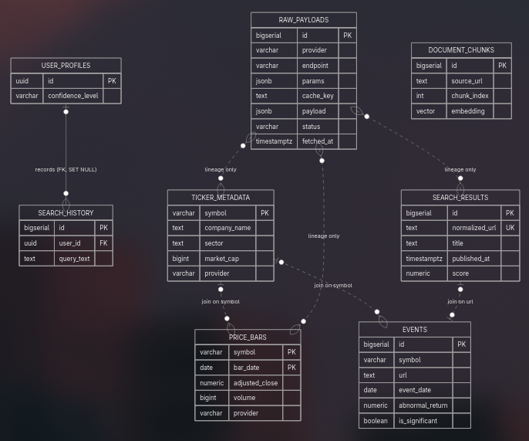
C. Logical Data Model
Describe how the conceptual model was transformed into a logical data model.
Relational Schema (if applicable)
Table | Primary Key | Foreign Keys
raw_payloads | id BIGSERIAL | indexes on (provider, cache_key, fetched_at DESC) and (provider, fetched_at)
ticker_metadata | symbol | —
price_bars | (symbol, bar_date) | CHECK all prices ≥ 0, high >= low; index on bar_date DESC
search_results | id BIGSERIAL | UNIQUE normalized_url
events | id BIGSERIAL | index on (symbol, event_date)
user_profiles | id UUID | —
search_history | id BIGSERIAL | user_id → user_profiles.id ON DELETE SET NULL
document_chunks | id BIGSERIAL | UNIQUE (source_url, chunk_index); embedding vector(1536)
Document Schema (if applicable)
Collection | Document Structure
raw_payloads.payload | The provider's response verbatim (Alpha Vantage Meta Data + Time Series (Daily) dict; yfinance rows list; Tavily results[])
raw_payloads.params | Request parameters minus the API key
document_chunks.metadata | Free-form chunk attributes (Sprint 4)
Graph Schema (if applicable) - not applicable
Node Types
Node Type | Description
Relationship Types
Relationship | Description
Time-Series Schema (if applicable)
Measurement | Tags | Fields
Daily bar | symbol, provider | open, high, low, close, adjusted_close, volume
D. Schema Design Decisions
Discuss important database design decisions.
- Every API call writes to raw_payloads first, including failures. Normalized tables are derived from it.
- dedup.drop_duplicates() removes duplicates within a batch (normalized URL first, then normalized title + publish date). UNIQUE(normalized_url) catches duplicates across batches; the upsert uses COALESCE so a later copy fills in missing content or published_at without overwriting good data.
- Pydantic models reject bad rows at normalized time (negative prices, open/close outside [low, high], symbol mismatch between request and Alpha Vantage Meta Data). Postgres CHECK constraints are the backstop.
- Unfinished session bars skipped: yfinance returns today's partial bar during market hours; fetch_history drops any row dated today so only final bars are stored.

3. Database Technology Evaluation
A. Candidate Technology Evaluation
Evaluate candidate storage technologies considered for your project.
Technology | Potential Role | Advantages | Limitations
Relational Database - PostgreSQL | Primary store | constraints enforce dedup/validity; JSONB covers raw payloads; pgvector extension | Needs a running server
Document Database - MongoDB | Raw payload archive | Natural fit for nested JSON | Second database; weak joins; Postgres JSONB does the same job in one place
Graph Database - Neo4j - maybe | Ticker–article relationships | Relationship traversal | Our relationships are one hop, so a join works
Time-Series Database - TimescaleDB | Price bars | Compression, time buckets | ~19 tickers × a few thousand bars is tiny, so a date index is enough
Data Lake / Lakehouse | Raw archive | Scales to huge volumes | Overkill; raw_payloads is a few MB
Vector Database | Embeddings | Purpose-built ANN search | Separate service and data copy; citations need a second lookup; pgvector removes all three
B. Technology Selection
Identify the technologies selected for implementation.
Selected Technologies
Technology | Purpose
PostgreSQL 16 | Source of truth: raw payloads, normalized tables, future vectors
pgvector | Embedding storage and cosine similarity (Sprint 4)
pgcrypto | gen_random_uuid() for user IDs
Redis 7 | Short-TTL response cache (health + demo endpoints wired; response caching is future work)
psycopg 3 | Postgres driver; executemany for batch upserts
Pydantic 2 | Record validation and normalization
httpx | HTTP client for Alpha Vantage and Tavily
yfinance 1.7 | Price history and company metadata
pytest | 86 offline tests against JSON fixtures; integration tests run against a live Postgres when TEST_DATABASE_URL is set
Docker Compose | One-command orchestration with health checks and persistent volumes
For each selected technology, explain:
- Why was it selected?
- Which project data will it store?
- Which application requirements does it support?
- Which future AI capabilities does it enable?
PostgreSQL + pgvector
- Why: One database for everything, including raw JSON and vectors. Constraints do dedup and validation for free.
- Data: all eight tables.
- Requirements: idempotent ingestion, API budget tracking, replay without network, event/price joins, cited retrieval.
- Future AI: embedding query for semantic search and RAG; events as the feature source for significance classification.
Redis
- Why: Standard cache; tiny container. Rate-limit protection is the top project risk.
- Data: cache keys like price-bars:{SYMBOL}, invalidated on upsert.
- Future AI: caching agent tool results within a conversation.

4. Database Architecture
A. Storage Layer Architecture
Describe how data will be organized across storage systems.
Insert architecture diagram below:
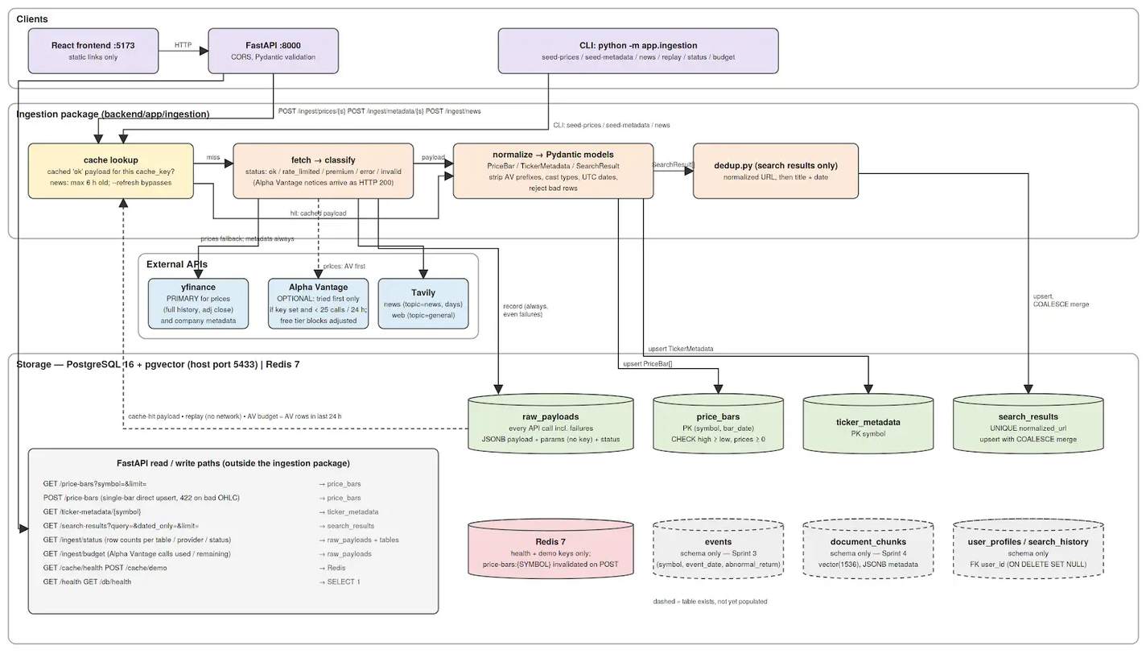
B. Data Flow Description
Explain how data moves through the storage architecture.
Data Ingestion: A request (CLI or POST /ingest/...) names a symbol or query. The pipeline checks raw_payloads for a cached ok response under the provider's cache key (news results expire after 6 hours; prices and metadata don't expire unless --refresh). On a miss it calls the provider, records the response and its classified status, and only then normalizes. For prices: Alpha Vantage is tried first only if a key is set and fewer than 25 calls were made in the last 24 h; otherwise, or on rate_limited/premium/error, it falls back to yfinance. Every call, even a failed one, is recorded and counts against the budget.
Data Storage: Normalized rows upsert into their tables. price_bars conflicts on (symbol, bar_date) and overwrite; search_results conflicts on normalized_url and merge with COALESCE; ticker_metadata conflicts on symbol and overwrite.
Data Access and Querying: GET /price-bars?symbol=&limit=, GET /ticker-metadata/{symbol}, GET /search-results?query=&dated_only=&limit=, GET /ingest/status (row counts per table and per provider/status), GET /ingest/budget. Nothing outside the backend talks to Postgres.
Data Updates: --refresh or ?refresh=true bypasses the cache and re-fetches. Upserts set updated_at/fetched_at = now(). Schema changes after first boot go through backend/sql/migrations/ (001_raw_payloads.sql exists for volumes created before that table was added).
Future Processing Integration: Sprint 3 reads price_bars to compute daily returns and rolling volatility and writes events from dated search_results. Sprint 4 reads search_results and the terminology corpus and writes document_chunks. (this might be swapped now)
5. Database Implementation
Implement at least one core database component.
Implemented Components
Component | Technology
Eight-table schema with constraints, indexes, and a migration script | PostgreSQL 16, pgvector, pgcrypto
Ingestion package: three provider modules, pipeline with cache/budget/fallback, dedup, Postgres store, CLI | Python 3.12, Pydantic 2, httpx, yfinance, psycopg 3
FastAPI service: health, read, upsert, and ingestion endpoints | FastAPI 0.115
Test suite: 86 offline tests on fixtures; integration tests for the Postgres store | pytest
Containerized stack with health checks and persistent volumes | Docker Compose
Implementation Summary
Describe what was implemented.
Examples:
- Tables created
- Collections created
- Graph schema implemented
- Sample data loaded
- Storage buckets created
Tables created: raw_payloads, ticker_metadata, price_bars, search_results, events, user_profiles, search_history, document_chunks.
Provider modules (providers/alpha_vantage.py, yahoo.py, tavily.py) each expose fetch_*, classify, normalize_*, and cache_key. classify is what handles Alpha Vantage's habit of returning rate-limit and premium notices as HTTP 200.
pipeline.Ingestor orchestrates cache lookup, budget check, fetch, record, normalize, dedup, upsert, and replay.
dedup.normalize_url strips scheme, www., default ports, duplicate/trailing slashes, and tracking params (utm_*, fbclid, gclid, etc.), and sorts the remaining query string. normalize_title lowercases and strips punctuation. drop_duplicates applies URL then title+date.
CLI: budget, status, seed-prices [--tickers --refresh --no-fallback --dry-run], seed-metadata, news --query ... [--topic --days --max-results], replay. Default ticker list: 14 AI/tech stocks plus 5 benchmark ETFs.
Endpoints added: GET /ticker-metadata/{symbol}, GET /search-results, GET /ingest/budget, GET /ingest/status, POST /ingest/prices/{symbol}, POST /ingest/metadata/{symbol}, POST /ingest/news.
Screenshots / Evidence
Insert screenshots demonstrating implementation.
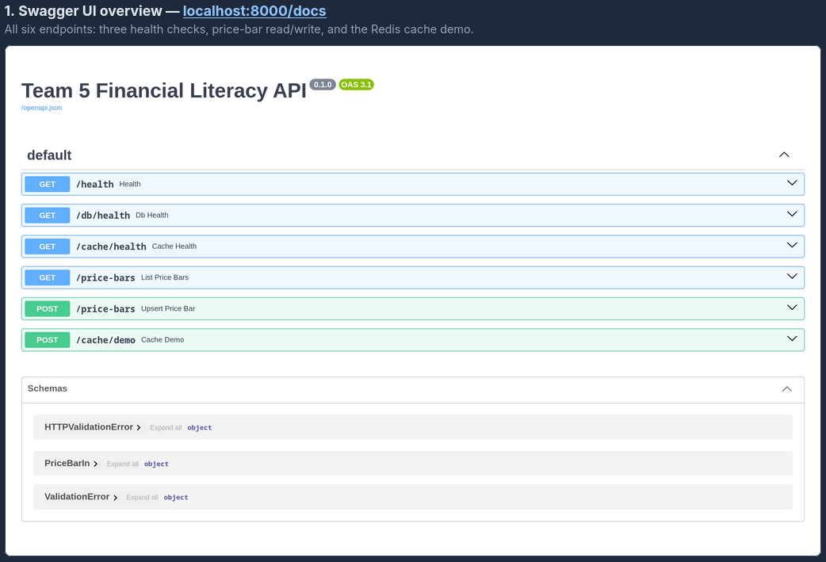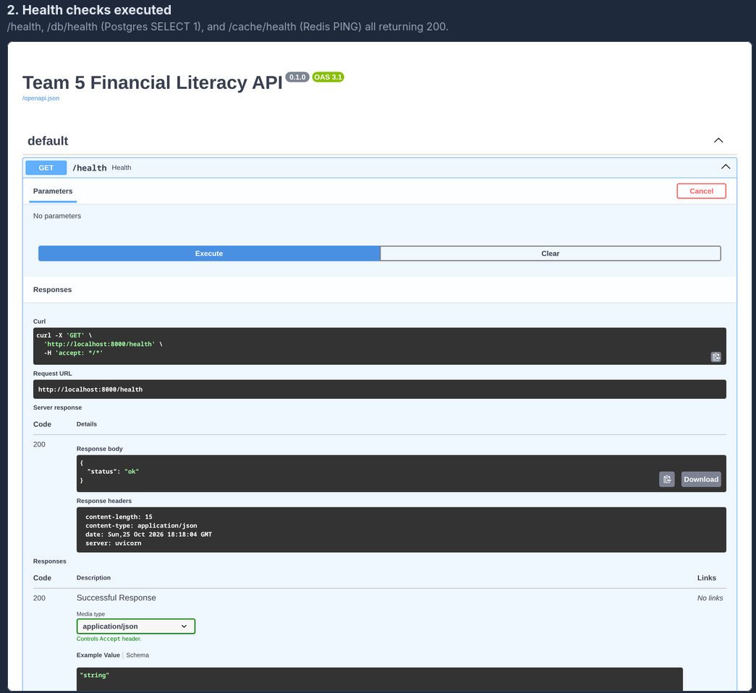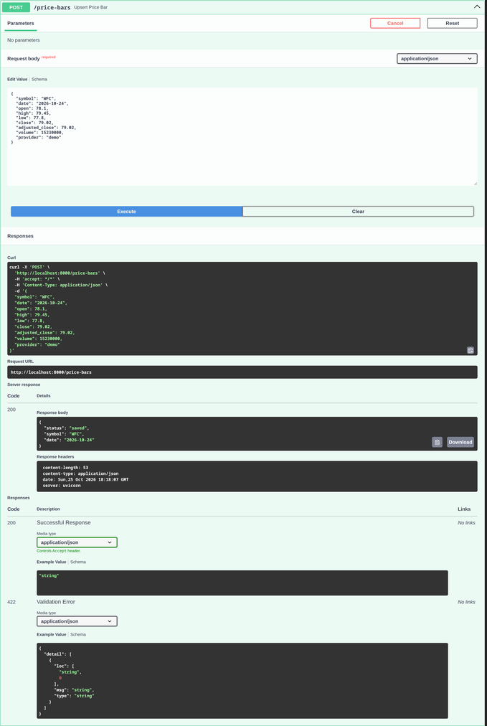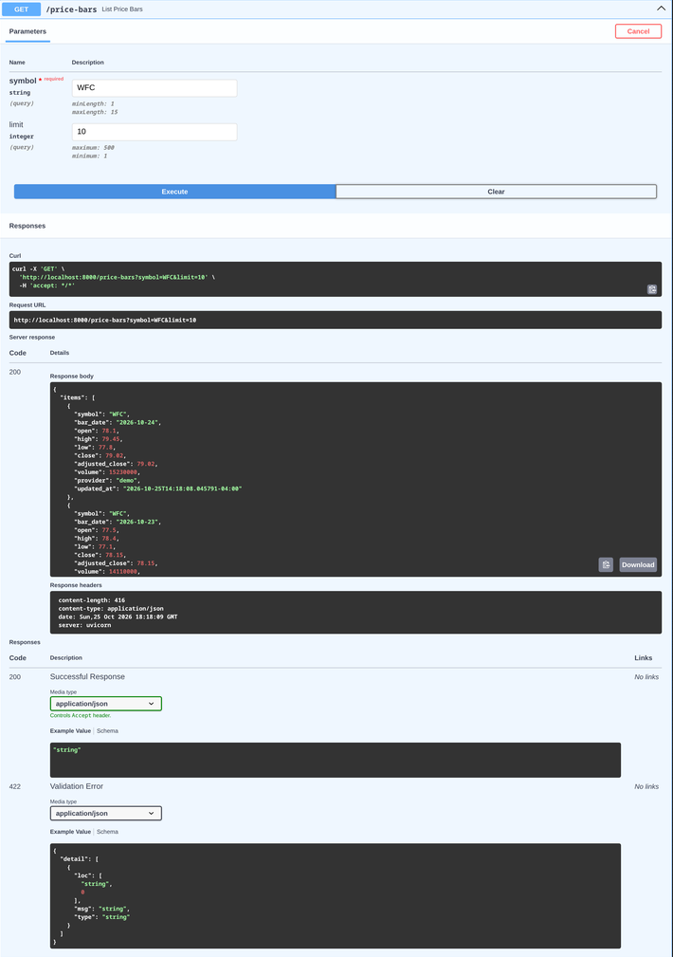
6. Query and Retrieval Demonstration
Demonstrate that the implemented database supports meaningful retrieval operations.
Provide at least three representative queries.
Query 1: Cache-first ingestion with provider fallback
Purpose: Show that the same request twice spends one API call, and that the pipeline records where data came from.
Query:
SELECT provider, endpoint, status, fetched_at
FROM raw_payloads WHERE params->>'symbol' = 'NVDA' ORDER BY fetched_at;

SELECT symbol, count(*) AS bars, min(bar_date), max(bar_date), provider
FROM price_bars WHERE symbol = 'NVDA' GROUP BY symbol, provider;
Result:
Second call returned "source": "cache" with the same 6,982 records and no provider contact.
First call: {"status": "fallback", "provider": "yfinance", "source": "api", "records": 6982, "message": "alpha_vantage premium"}
Second call: {"status": "ok", "provider": "yfinance", "source": "cache", "records": 6982}
raw_payloads for NVDA: alpha_vantage/TIME_SERIES_DAILY_ADJUSTED status=premium (free tier, counted against the 25/day budget), then yfinance/history status=ok.
price_bars: NVDA | 6982 bars | 1999-01-22 to 2026-10-23 | provider=yfinance
Query 2: Dedup across queries by normalized URL and title/date
Purpose: Two overlapping news queries store each article once.
Query:
SELECT count(*) AS raw_results
FROM raw_payloads, jsonb_array_elements(payload->'results')
WHERE provider = 'tavily';

SELECT count(*) AS stored, count(DISTINCT normalized_url) AS unique_urls,
count(published_at) AS dated
FROM search_results;
Result:
raw_results = 17 (8 + 9 across the two Tavily responses); stored = 14, unique_urls = 14, dated = 14.
Three articles returned by both queries were stored once via ON CONFLICT (normalized_url). Both ingest responses report "duplicates": 0 because that counter covers duplicates within a single provider response; cross-query overlap is absorbed by the upsert, so raw (17) vs stored (14) is the evidence.
Query 3: Validation rejects inconsistent data
Purpose: Bad rows never reach the table.
Query:
INSERT INTO price_bars (symbol, bar_date, open, high, low, close, adjusted_close, volume)
VALUES ('NVDA', '2026-10-20', 180, 175, 178, 179, 179, 1000);
-- -> ERROR: violates check constraint
Result:
API: HTTP 422 {"detail":"OHLC values are inconsistent"}
Database: ERROR: new row for relation "price_bars" violates check constraint "price_bars_check"
DETAIL: Failing row contains (NVDA, 2026-10-20, 180.000000, 175.000000, 178.000000, 179.000000, 179.000000, 1000, unknown, ...).
pytest -k test_normalize_adjusted_strips_prefixes_and_rejects_bad_rows: 1 passed (full suite: 86 passed, 2 integration tests pass against live PostgreSQL).
7. Storage Design for Future AI and Analytics (Forward-Looking)
This section is intended to help teams connect database design decisions to future analytics and AI capabilities. Responses are exploratory and may evolve in later sprints.
7.1 Potential Analytics and AI Use Cases
Based on project goals, identify potential analytics or AI capabilities that the system may support in future sprints.
Examples:
- Dashboard analytics
- Recommendation
- Forecasting
- Semantic search
- Question answering
- Retrieval-Augmented Generation (RAG)
- Knowledge discovery
- Trend analysis
- Decision support
Potential AI Capability | Why It May Be Useful for the Project
Semantic search | Beginner phrasing still finds the right definition or article
Question answering / RAG | Cited answers to "what does this term mean" from document_chunks
Knowledge discovery | Event/price join surfaces which dated news coincided with large moves
Classification | Significance flag on events; directive-language guardrail on agent output
Trend analysis | Daily returns and rolling volatility from price_bars
Recommendation (reading only) | Next terms or articles from search_history + financial_interests
Discussion
How do the project's data characteristics influence the types of analytics or AI capabilities that may be feasible?
The data is small, structured, and keyed by ticker and date. That makes rule-based features and retrieval feasible and model training unrealistic. The schema therefore invests in keys, constraints, raw archival, and a vector column rather than training-set tables.
7.2 How Storage Choices Support Future Capabilities
Discuss how the selected storage technologies may support future analytics or AI workloads.
Storage Technology | Data Stored | Potential Analytics / AI Support
PostgreSQL relational tables | Bars, metadata, search results, events, users | Feature generation (returns, σ30), event/price joins, confidence level for prompt conditioning
raw_payloads JSONB | Every API response | Re-normalize when Sprint 3/4 need fields not yet extracted (e.g., raw_content for chunking) without new API calls
pgvector document_chunks | Chunk text + 1536-dim embeddings + metadata | Cosine retrieval for semantic search and RAG; metadata filters by ticker or source
Redis | Cached responses | Keeps agent tool calls under rate limits
Examples:
- Relational databases support structured reporting and feature generation.
- Document databases support large text collections.
- Graph databases support relationship exploration and knowledge discovery.
- Time-series databases support forecasting and trend analysis.
- Data lakes support large-scale analytics.
- Vector databases support semantic retrieval and RAG.
Discussion
Which storage decisions were influenced by anticipated future analytics or AI needs?
raw_payloads, the provider tag, and the vector column were all added specifically for anticipated AI needs: cheap re-processing, better captions, and cited retrieval.
7.3 Potential Future Storage Components (Optional)
Identify storage technologies that may be added in future sprints if needed.
Examples:
- Vector databases
- Embedding stores
- Feature stores
- Knowledge graphs
- Data lakehouse platforms
Future Technology | Possible Purpose
Discussion
What additional storage capabilities might become necessary as the project evolves?
8. Updated System Architecture
Update the high-level architecture based on Sprint 2 decisions.
Data Sources (yfinance primary, Alpha Vantage optional, Tavily) → Ingestion Layer (app.ingestion: fetch → classify → raw_payloads → normalize → dedup → upsert) ← implemented → Storage Layer (PostgreSQL 16 + pgvector, 8 tables; Redis) ← implemented → Processing Layer (Sprint 3: returns, volatility, event windows) → AI & ML Layer (Sprint 4: embeddings, retrieval, agent, guardrail) → User Application (FastAPI backend implemented; React frontend scaffolded)
Insert updated architecture diagram below.
Architecture Changes Since Sprint 1
Describe changes made and the rationale behind them.
Change | Rationale
yfinance is the primary price source; Alpha Vantage optional | Alpha Vantage free tier returns a "premium endpoint" notice for TIME_SERIES_DAILY_ADJUSTED; adjusted close is required for returns
raw_payloads table added | Parser fixes and re-processing cost zero API calls; budget is computed from it
Single Postgres + pgvector instead of relational + separate vector store | Fewer services; citations are a join
benchmark_bars folded into price_bars | ETFs are tickers
Dedup as a tested function plus a UNIQUE constraint | Within-batch and cross-batch duplicates both handled
Ingestion exposed via CLI and /ingest/* endpoints | Same code path for scripted seeding and the demo
9. Team Contributions
Work Completed:

Team Member | Tasks Completed
Josh | Ingestion layer implementation
Himaja | Database design and implementation
Jayden | Persistant data layer
Michael | Web URL Normalization
10. Reflection
Lessons Learned
What did your team learn about database design and technology selection?
Storing raw responses before normalizing changed how we think about the API budget. Validation in layers (Pydantic, then CHECK constraints) catches different mistakes with different error messages. The free tier that looked sufficient on paper (25 calls/day) was useless in practice because the endpoint we needed is gated, which is why the fallback provider became the primary one.
Challenges Encountered
Describe challenges encountered and how they were addressed.
Alpha Vantage’s free tier returns a “premium endpoint” notice for the adjusted daily series, which we need for split-adjusted returns. We switched to yfinance as the primary price source and kept Alpha Vantage as an optional, budget-guarded first attempt.
Alpha Vantage reports rate limits and errors as HTTP 200 responses, so the parser treated them as empty data. We added a classify step that inspects the payload before parsing.
init.sql only runs when the Postgres volume is first created, so adding raw_payloads after teammates had already started the stack required a migration script.
Scheduling: meeting early in the sprint was hard again, which pushed integration toward the end. We can hopefully get ahead of the next sprint.
11. Sprint Exit Checklist
Requirement | Completed
Conceptual model completed | □
Logical schema completed | □
Database technology evaluation completed | □
Storage architecture designed | □
Core database component implemented | □
Example queries demonstrated | □
AI workload alignment discussed | □
Updated architecture documented | □
Sprint report completed | □
Peer evaluation form submitted | □

Sprint 3 Distributed Processing and Data Pipelines
Team Members:

Name | Role(s) | Contribution Area

1. Processing Requirements Analysis
1.1 Review of Previous Sprints
Data Sources (Sprint 1)
Briefly summarize the project's data sources.
Data Source | Type | Format | Size | Update Frequency
Storage Architecture (Sprint 2)
Briefly summarize the database/storage systems implemented.
Storage Technology | Purpose | Data Stored
Major Data Types
Examples: Structured, semi-structured, text, images, time-series, graph data.
Data Type | Description
Expected Query and AI Workloads
Describe the major analytics and AI tasks your system will support.
Examples:
- Dashboard analytics
- Recommendation
- Forecasting
- Semantic search
- RAG
- Question answering
1.2 Processing Challenges
Identify the major processing requirements.
Requirement | Description | Importance to Project
Data cleaning
Data integration
Aggregation
Feature preparation
Text preparation
Time-series processing
Streaming updates
Discussion
Describe the most important processing challenges and explain why they are necessary for your project.
2. Data Pipeline Design
2.1 End-to-End Pipeline Architecture
Provide a diagram illustrating the overall processing workflow.
Insert Architecture Diagram Here
Pipeline Overview
Describe the overall data flow.
Data Sources
→ __________
→ __________
→ __________
→ Analytics / AI Services
2.2 Bronze / Silver / Gold Design
Bronze Layer (Raw Data)
Describe how raw data is stored.
Data Source | Storage Location | Format
Brief description:
Silver Layer (Cleaned and Standardized Data)
Describe cleaning and transformation activities.
Examples:
- Data validation
- Missing value handling
- Deduplication
- Standardization
- Schema alignment
Transformation | Purpose
Brief description:
Gold Layer (Business and AI-Ready Data)
Describe analytical or AI-ready outputs.
Examples:
- Aggregated tables
- Feature tables
- Training datasets
- Search-ready document collections
- Recommendation datasets
Description:
Dataset | Purpose | Description
2.3 Scalable Data Flow Description
Describe:
Data Origin:
Data Ingestion:
Data Transformations:
Data Storage:
AI Consumption:
3. Processing Technology Evaluation
3.1 Technology Evaluation
Evaluate technologies considered for the project.
Technology | Potential Role | Advantages | Limitations
Python/Pandas
Apache Spark
Spark Streaming (if applicable)
Apache Flink (if applicable)
Cloud-Native Processing Services (if applicable)
Other
3.2 Technology Selection
Describe the technologies selected for implementation.
Selected Technologies
Technology | Purpose
Justification
For each selected technology, explain:
- Why it was selected
- Processing tasks performed
- Scalability considerations
- Future expansion possibilities
4. ETL Pipeline Implementation
4.1 Pipeline Overview
Pipeline Name:
Inputs
Source | Description
Transformations:
Transformation | Purpose

Transformation | Purpose
Outputs
Output Dataset | Purpose
4.2 Pipeline Workflow
Insert workflow diagram or screenshot here.

4.3 Transformation Details
Structured Data Processing if Applicable
Describe any of the following:
- Filtering
- Cleaning
- Joins
- Aggregations
- Feature generation
Semi-Structured Data Processing if Applicable
Describe any of the following:
- JSON flattening
- Metadata extraction
- Schema normalization
Text Data Processing if Applicable
Describe any of the following:
- Text cleaning
- Metadata enrichment
- Corpus preparation
- Document segmentation
Time-Series Processing if Applicable
Describe any of the following:
- Resampling
- Window creation
- Trend calculations

4.4 Implementation Evidence
Provide evidence of implementation.
Code Snippets
Insert representative code snippets.
Screenshots
Insert screenshots.
Sample Outputs
Insert sample outputs.
5. Distributed Processing Demonstration
5.1 Processing Framework
Indicate the processing framework used.
☐ Python/Pandas
☐ Apache Spark
☐ Spark Streaming
☐ Apache Flink
☐ Cloud Service
☐ Other: __________________
5.2 Demonstration
Describe how distributed or scalable processing concepts were applied.
Examples:
- Partitioned processing
- Parallel transformations
- Distributed aggregations
- Window operations
- Streaming pipelines
5.3 Processing Results
Input Dataset
Dataset | Size
Processing Steps

Output Dataset
Dataset | Size:
6. Preparing Data for Future AI and Analytics
This section is intended to help teams evaluate how the processing layer supports future analytics and AI capabilities. Responses may be refined further during Sprint 4 (AI and Machine Learning Integration).
6.1 Potential Analytics and AI Capabilities
Identify the analytics or AI capabilities that the project may support in future sprints.
Capability | Description
Examples:
- Dashboard analytics
- Recommendation
- Forecasting
- Classification
- Semantic search
- Question answering
- Retrieval-Augmented Generation (RAG)
- Knowledge discovery
- Trend analysis
6.2 AI-Ready Data Preparation
Describe how the processing pipeline prepares data for future analytics or AI workloads.

AI Capability | Required Data | Processing Pipeline Support
Examples:
- Feature engineering for machine learning
- Data aggregation for recommendation systems
- Text cleaning and corpus preparation
- Document chunking for semantic retrieval
- Metadata enrichment
- Relationship extraction
- Time-window generation for forecasting
- Training dataset preparation
Discussion
Explain how the Bronze/Silver/Gold workflow and ETL pipelines contribute to producing analytics-ready or AI-ready data.
6.3 Future Processing Enhancements (Optional)
Describe processing capabilities that may be added in later sprints.
Examples:
- Streaming analytics
- Feature stores
- Embedding generation pipelines
- Real-time recommendation pipelines
- Agentic workflow orchestration
- Automated model retraining pipelines
- Data quality monitoring pipelines
Future Capability | Potential Purpose
Discussion
What additional processing requirements might emerge as the project evolves toward AI integration and deployment?
7. Updated System Architecture
7.1 Updated Architecture Diagram
Insert updated architecture diagram.
Data Sources
→ Ingestion Layer
→ Storage Layer
→ Processing Layer
→ AI & ML Layer
→ User Application
7.2 Architectural Revisions
Change | Reason
Discussion
Explain how Sprint 3 influenced the architecture.
8. Reflection and Data Engineering Considerations
8.1 Scalability Considerations
Discuss how the processing architecture would scale if data volume or workload increased.
Questions to consider:
- How would the pipeline handle approximately 10× more data?
- How would the pipeline handle approximately 100× more data?
- Which components would become bottlenecks?
- What architectural changes might be required?
Examples:
- Additional Spark workers
- Data partitioning
- Distributed storage
- Stream processing
- Incremental processing
8.2 Reliability and Fault Tolerance
Discuss how the processing system handles failures.
Questions to consider:
- What happens if a processing job fails?
- What happens if data arrives late or contains errors?
- How could failed jobs be restarted?
- How could data loss be minimized?
Examples:
- Checkpointing
- Job retries
- Logging and monitoring
- Backup storage
- Reprocessing pipelines
8.3 Data Governance and Pipeline Management (Optional)
Reflect on practices that would improve the maintainability and trustworthiness of the pipeline.
Topics may include:
- Data quality monitoring
- Data lineage and provenance
- Pipeline observability
- Metadata management
- Access control
- Auditability
Students are not expected to fully implement these capabilities but should discuss how they might be addressed in a production environment
8.4 Lessons Learned
What worked well?
Describe successful design choices, technologies, or implementation approaches.
Challenges Encountered
Describe technical, organizational, or data-related challenges.
Future Improvements
If this system were deployed in a production environment, what improvements would you make?
9. Team Contributions
Responsibilities
Team Member | Responsibilities
Tasks Completed
Team Member | Tasks Completed
Challenges Encountered
Describe technical and organizational challenges.
Planned Work for Sprint 4
Describe preparation for:
- AI integration
- Machine learning
- Embedding generation
- Vector databases
- RAG pipelines
- Other AI capabilities
Sprint 3 Completion Checklist
☐ Processing requirements analyzed
☐ End-to-end pipeline architecture designed
☐ Bronze/Silver/Gold organization documented
☐ Processing technology selection justified
☐ ETL pipeline implemented
☐ Distributed/scalable processing demonstrated
☐ AI-ready data preparation discussed
☐ Updated architecture completed
☐ Team contributions documented
☐ Sprint report completed

Sprint 4 AI and Machine Learning Integration
Team Members:

Name | Role(s) | Contribution Area
1. AI Requirements Analysis
1.1 Review of Previous Sprints
Summarize the assets available entering Sprint 4.
Data Assets
- Major datasets
- Gold-layer datasets (Sprint 3 outputs)
- Feature datasets (if applicable)
- Text/document corpora (if applicable)
- Knowledge resources (if applicable)
Processing Assets
- ETL pipelines (Sprint 3)
- Data transformation workflows
- Aggregation pipelines
- Feature engineering workflows
- Streaming pipelines (if applicable)
Existing Architecture
Briefly describe the system entering Sprint 4:
Data Sources
→ Storage Layer
→ Processing Layer
→ AI Layer (to be implemented in Sprint 4)
→ User Application
1.2 AI Capability Selection (Required)
Each team must implement at least one AI capability.
AI Capability | Example
Classification | Spam detection
Prediction | Demand forecasting
Recommendation | Personalized suggestions
Semantic Search | Intelligent search
Question Answering | Knowledge assistant
RAG | Document-based chatbot
Knowledge Discovery | Pattern/graph insights
Selected AI Capability
- Chosen Capability: __________
- Justification: __________
Problem Statement
What problem does this AI component solve?
Intended Users
Who benefits from this capability?
Expected Outputs
What does the AI system produce?
2. AI Architecture Design
2.1 AI Workflow Architecture
Design how AI is integrated into the existing data system.
General Pattern (End-to-End)
Data Sources
→ Storage Layer
→ Processing Layer
→ AI Component
→ User Application
Implementation Pattern (choose one or more)
Option A: ML-Based Pipeline
Gold Dataset
→ Feature Engineering
→ ML Model (e.g., Spark MLlib / sklearn)
→ Predictions
Option B: Embedding-Based Pipeline
Documents
→ Spark ETL
→ Chunking
→ Embedding Model
→ Vector Database
→ Semantic Search
Option C: RAG Pipeline
Documents
→ ETL + Chunking
→ Embedding Generation
→ Vector Database
→ Retriever
→ LLM
→ Response Generation
Insert architecture diagram here.
2.2 AI Technology Selection
Component | Technology
ML Framework
Embedding Model
Vector Database
LLM (if used)
Retrieval Framework
Other
Justification
Explain:
- Why each component was selected
- Role in the system
- Scalability considerations
- Future extensibility
3. AI Capability Implementation
Implement at least ONE AI capability. Partial implementation with clear pipeline design is acceptable if justified.
Option A: Machine Learning Workflow
Dataset
- Features:
- Labels (if applicable):
- Dataset size:
Model Selection
(e.g., Logistic Regression, Random Forest, Spark MLlib, etc.)
Feature Engineering
- Feature extraction
- Encoding / normalization
- Feature selection
Training and Inference
- Training process
- Validation approach
- Inference workflow
Option B: Embedding + Semantic Retrieval
Document Preparation
- Corpus creation
- Cleaning
- Chunking strategy
Embedding Generation
- Model used
- Embedding workflow
- Output format
Retrieval System
- Vector database
- Indexing strategy
- Similarity search method
Option C: RAG Pipeline
Knowledge Base Preparation
- Sources
- Chunking strategy
- Metadata design
Retrieval Pipeline
- Retriever type
- Top-k selection
- Similarity search
Generation Pipeline
- LLM used
- Prompt strategy
- Response generation
4. AI Capability Demonstration
Provide evidence of working system.
Include:
- Sample inputs
- Outputs
- Screenshots
- Code
Machine Learning
- Predictions / classification outputs / forecasts
Semantic Search
- Queries
- Retrieved results
- Ranking outputs
RAG
- User question
- Retrieved context
- Generated response
5. AI Capability Evaluation
Evaluation Metrics
Task Type | Metrics
Classification | Accuracy, Precision, Recall, F1
Regression | RMSE, MAE
Retrieval | Recall@K, Precision@K
Semantic Search | Relevance, Top-K quality
RAG | Groundedness, Answer quality
Results
Metric | Value
Discussion
- What worked well
- Key limitations
- Improvement opportunities
6. AI Infrastructure Considerations
6.1 Scalability
Discuss:
- 10× data scaling
- 100× data scaling
- Inference scaling
- Retrieval scaling
6.2 Operations & Maintenance
- Model retraining strategy if applicable
- Embedding refresh if applicable
- Index updates if applicable
- Monitoring quality
6.3 Responsible AI
- Bias
- Data quality
- Hallucination risk (if LLM used)
- Explainability
- Privacy concerns
7. Updated System Architecture
Update full system:
Data Sources
→ Ingestion Layer
→ Storage Layer
→ Processing Layer
→ AI Layer
→ User Application
Include:
- ML models if applicable
- Embedding pipeline if applicable
- Vector database if applicable
- RAG components if applicable
Architectural Changes (if applicable)
Change | Reason
8. Reflection & Sprint 5 Preparation
Challenges
- Technical challenges
- Integration challenges
Lessons Learned
- AI integration into data systems
- Data → model → inference pipeline understanding
Sprint 5 Preparation
- End-to-end integration
- Deployment
- UI integration
- System testing
- Optimization
9. Team Contributions
Member | Responsibilities

Member | Tasks Completed
10. Sprint Exit Criteria Checklist
Requirement | Completed
One AI capability implemented | □
AI architecture integrated with Sprint 1–3 pipeline | □
Working demonstration provided | □
Evaluation included | □
Scalability discussed | □
System architecture updated | □
Team contributions documented | □
Sprint report completed | □

Sprint 5 End-to-End Integrated Deployment and System Evaluation
Team Members:

Name | Role(s) | Contribution Area

1. Core Focus: End-to-End System Integration
1.1 System Overview
Briefly describe your complete system and its purpose.
- Problem being solved:
- Target users:
- High-level system description:
1.2 End-to-End Pipeline
Provide a clear description of the full pipeline:
Data Sources → Ingestion → Storage → Processing → AI Layer → User Application
Describe:
- How data flows through the system:
- How components are connected:
- How AI is triggered in the system:
1.3 System Interaction Flow
Clearly describe how users interact with the system.
Example interaction type (select one or more):
☐ Search / Recommendation System
☐ RAG-based Assistant
☐ Machine Learning Prediction System
☐ Other: ___________
User Interaction Flow
Describe step-by-step:
User → UI → Backend → AI/Processing → Output
Explanation:
1.4 Integration Summary
Confirm integration status:
☐ All components integrated into a single system
☐ APIs/services properly connected
☐ Data flows across all layers
☐ AI components use real pipeline outputs
☐ No isolated notebooks remain
Notes / Explanation:
2. Deployment and System Packaging
2.1 Deployment Strategy
Select deployment type:
☐ Local deployment
☐ Cloud deployment
☐ Containerized deployment (Docker / Docker Compose)
Describe your deployment approach:
2.2 System Setup Instructions
Provide step-by-step instructions:
Environment Setup
- Python version:
- Dependencies:
- Setup command(s):
How to Run the System

Access Points
- Backend API:
- Frontend/UI:
- Other services:
2.3 Deployment Components Checklist
Confirm:
☐ Runnable system (not notebooks)
☐ Environment configuration provided
☐ Backend service/API running
☐ UI/dashboard working
☐ Reproducible execution steps
Notes:
3. End-to-End AI Functionality Demonstration
3.1 AI Capability Implemented
Select at least one:
☐ Machine Learning (classification/prediction)
☐ Embedding-based semantic search
☐ Retrieval-Augmented Generation (RAG)
☐ Recommendation system
☐ Knowledge discovery
☐ Other: ___________

3.2 AI Workflow Description
Describe how AI works inside your system:
- Input:
- Processing steps:
- Model / method used:
- Output:
3.3 Data Dependency Requirement
Confirm:
☐ AI uses real system data (not demo-only data)
☐ AI is integrated into pipeline
☐ AI is accessible via UI or API
Explanation:
3.4 Demonstration Evidence
Include:
- Screenshots:
- Example inputs:
- Example outputs:
4. System Evaluation
4.1 Performance and Scalability
Discuss:
- End-to-end latency:
- Inference or retrieval speed:
- Behavior under increased data (10× scenario):
- Bottlenecks:
4.2 System Robustness
Discuss:
- Failure points in system:
- Handling missing/invalid inputs:
- Recovery strategy:
4.3 Usability Evaluation
Discuss:
- Ease of use:
- UI clarity:
- Quality of AI responses:
5. Optional Advanced Component: Agentic AI Workflow
(Optional Section – Bonus Only)
Indicate if used:
☐ Yes
☐ No
5.1 Agentic AI Description
If applicable, describe:
- Agent role:
- Tools used (DB, API, vector DB, etc.):
- Workflow:
5.2 Agent Workflow Diagram (Optional)
User → Agent → Tools → LLM → Response
Description:
5.3 Scope Clarification
Confirm:
☐ Agentic AI is optional extension
☐ Core system works without agent
☐ Agent does not replace required AI component
6. Integration Across System Layers
6.1 System Integration Checklist
Confirm integration of:
☐ Frontend (UI)
☐ Backend services (API)
☐ Databases (SQL / NoSQL / vector DB)
☐ Data pipelines (Sprint 3)
☐ AI components (Sprint 4)
☐ Deployment environment
6.2 Integration Summary
Describe how all components work together:
7. Updated System Architecture
7.1 Final Architecture Diagram
Insert updated architecture diagram:
(Data Sources → Ingestion → Storage → Processing → AI Layer → Application → Deployment)
7.2 Architecture Components Included
Check all that apply:
☐ Machine Learning models
☐ Embedding pipeline
☐ Vector database
☐ RAG pipeline
☐ API/service layer
☐ User interface
7.3 Architectural Changes if Applicable
Change | Reason

8. Reflection and Preparation for Final Demonstration
8.1 Key Challenges
Describe:
- Integration challenges:
- Deployment challenges:
- Debugging issues:
8.2 Lessons Learned
Reflect on:
- System integration insights:
- Scalability considerations:
- Design tradeoffs:
8.3 Final Demo Preparation
Confirm readiness for:
☐ Live system demonstration
☐ Individual interview(s)
☐ End-user interaction
☐ Full pipeline explanation
☐ Scalability discussion
Notes:
9. Sprint Exit Checklist
Requirement | Completed
Fully integrated end-to-end system | □
Working deployment (local/cloud/container) | □
Functional AI capability integrated | □
UI connected to backend | □
System-level evaluation completed | □
Updated architecture diagram | □
User interaction flow clearly defined | □
Scalability and performance discussed | □
System ready for final demonstration | □
Peer evaluation form submitted | □

